**ARCHITECTURE VIEWS**

The two different architecture views to explore the university marketplace ‘DonHub’: the Logical View and the Physical View.

1. **Logical View:** The logical view focuses on the conceptual structure and relationships between the major entities of the DonHub. It abstracts away the physical details and provides an overview of how the different modules interact and depend on each other.

- **User Management:** Manages user information and permissions.

Key Entities and Attributes: **User** (name, emailId, phoneNo, address, profilePic, password, isAdmin)

- **Product Management:** Overviews the listing. Categorization, and state of products available in the marketplace

Key Entities and Attributes: **Product** (name, description, image, video, condition, category, price, sellerId, timestamp)

**- Transaction Management:** Handles the buying and selling interactions and records of transactions between users.

Key Entities and Attributes: **Transaction** (buyerId, sellerId, productId, price, transactionStatus, paymentMode, timeStamp)

**- Relationships:** Details how the primary entities interact and depend on each other

Key Relationships:

1. **User to Product:** One-to-many relationship, as one user can list multiple products. Represented by the ‘sellerId’ in the Product entity linking back to the ‘userId’ in the User entity.
2. **User to Transaction:** One-to-many relationships for both buying and selling. A user can make multiple purchases and sales. The ‘buyerId’ and ‘sellerId’ in the Transaction entity refer to the ‘userId’ in the User entity.
3. **Product to Transaction:** One-to-one relationship. A specific product listing can result in one transaction (assuming a product is sold once). The ‘productId’ in the Transaction entity links back to the ‘productId’ in the Product entity.

**Explanation:** The logical view of the DonHub university marketplace highlights the fundamental entities and the primary functionalities of managing users, products, and transactions, and estrablishes the relationships between these core entities. This view serves as a blueprint for understanding the system’s data interactions and serves as a foundation for database design, application development, and further system refinements.

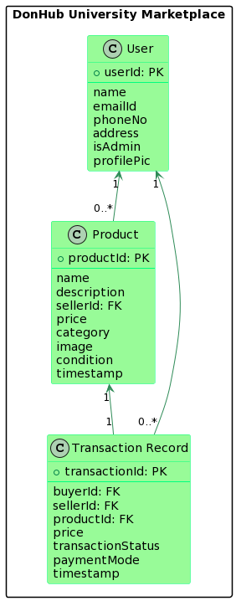

1. **Physical View:** The physical view displays how the software components are deployed across the system’s infrastructure, focusing on hardware, servers, and networking.

- **Client Devices:** These are the computers, tablets, or smartphones used by the students and staff to access the marketplace.

**- Web Servers:** Host the core application logic of DonHub, processing user requests and rendering the appropriate views.

**- Database Servers:** Store all the persistent data related to users, product listings, chats, etc.

**- Load Balancers:** Distribute incoming traffic across multiple servers, ensuring that the system remains responsive even under heavy load.

- **CDN (Content Delivery Network):** Ensures faster content delivery by caching static assets closer to the user’s location.

**Explanation:** The physical view is essential for system administrators, infrastructure architects, and IT personnel. It provides insights into how the ‘DonHub’ platform’s software components map onto the hardware, ensuring performance, scalability, and resilience. For instance, load balancers are crucial in handling peak times, such as when students might be preparing for a new academic year and buying/selling textbooks en masse.

